Stonnall Neighbourhood Plan Review 2024-2043

Our Village

Contents
1.0 INTRODUCTION 1
1.1 What is a Neighbourhood Plan? 1
1.2 How a Neighbourhood Plan fits into the Planning System 1
1.3 The Neighbourhood Plan Area 1
1.4 How the Plan is organised 2
1.5 Next steps 2
2.0 THE METHODOLOGY 4
2.1 Why does the Stonnall area need a Neighbourhood Plan? 4
2.2 How the Plan has been prepared 4
2.3 The Vision for the Neighbourhood Plan 4
2.4 The Aims of the Neighbourhood Plan 5
3.0 ABOUT STONNALL NEIGHBOURHOOD AREA 6
3.1 Setting 6
3.2 Our History 6
3.3 Stonnall Neighbourhood Area Today 6
4.0 POLICY CONTEXT 8
4.1 National Planning Policy Framework 8
4.2 Lichfield District Local Plan: Our Strategy (2008-2029) 8
5.0 HOUSING 9
5.1 Policy H1 9
5.2 Policy H2 9
5.3 Policy H3 10
6.0 DESIGN 12
7.0 TRANSPORT 13
7.1 Policy T1 13
8.0 BETTER LOCAL SHOPS 14
8.1 Policy LSH1 14
8.2 Policy LSH2 14
9.0 HEALTH CARE 16
9.1 Policy HC1 16
10.0 BETTER LOCAL COMMUNITY FACILITIES 17
10.1 Policy CF1 17
10.2 Policy CF2 17
10.3 Policy CF3 18
11.0 HISTORIC ENVIRONMENT 20
11.1 Policy HB1 20
11.2 Policy HB2 21
11.3 Policy HB3 21
12.0 LANDSCAPE AND ENVIRONMENT 22
12.1 Policy LE1 22
12.2 Policy LE2 23
12.4 Policy LE4 24
13.0 SHIRE OAK QUARRY 26
14.0 NON LAND USE POLICIES 27
14.1 Non Land Use Policy 1 – ’Smarter’ travel choices 27
14.2 Non Land Use Policy 2 – HGV/LGV traffic 27
14.3 Non Land Use Policy 3 – Local traffic issues 28
14.4 Non Land Use Policy 4 - Health 29
14.5 Non Land Use Policy 5 – Community Facilities 29
15.0 DELIVERING THE PLAN 31
Appendix A Glossary 32
Appendix B Stonnall Design Guide 34

1.0 INTRODUCTION

1.1 What is a Neighbourhood Plan?
Neighbourhood Plans are one part of the planning system and aim to give local people more say about what goes on in their area. The development of a Neighbourhood Plan is not imposed from above, but is an opportunity for communities to set out the way they see the future of their Neighbourhood Area.

A Neighbourhood Plan is a formal and positive plan for development which allows communities to shape the local area in a way which suits their local needs. It can cover a single issue or a range of issues depending what is important to the community. Neighbourhood planning allows communities to work through their local Parish Council to identify for example where they think any possible new homes should go, how transport and highways can be improved, which areas need improving and what should be protected. The Neighbourhood Plan however must broadly conform with Lichfield District Council’s local plan and the Government’s National Planning Policy Framework.

The first Stonnall Neighbourhood Plan set out a vision for the future of the village and its rural surroundings, providing a strategy and land-use planning framework to guide development within the neighbourhood plan area for the period 2014 to 2029. It was ‘made’ in April 2016. This Neighbourhood Plan Review represents the first update of that plan, recognising that over time, plans become out of date. The new plan will cover the period to 2043.

The Plan has been developed through extensive consultation with the people of Stonnall Neighbourhood Area and others with local interest.

1.2 How a Neighbourhood Plan fits into the Planning System
The Neighbourhood Planning Regulations contain a number of basic conditions with which all neighbourhood plans must be in line. A Neighbourhood Plan must therefore:
- have appropriate regard to national policy (National Planning Policy Framework)
- contribute to the achievement of sustainable development
- be in general conformity with the strategic policies in the development plan for the local area (Lichfield District Council’s Local Plan)
- be compatible with human rights requirements
- not have a significant effect on a European Site (as defined in the Conservation of Habitats and Species Regulations 2017) .

The Neighbourhood Plan, once ‘made’, forms part of the District’s Local Development Plan.

1.3 The Neighbourhood Plan Area
The policies within this Neighbourhood Plan are related to the designated Neighbourhood Area. The Stonnall Neighbourhood Area was designated on 19th February 2013 and is shown on the map below. This is the same area as covered by the 2016 Neighbourhood Plan.

The Neighbourhood Plan covers the time period 2024 – 2043 to correspond with the District Council’s emerging Local Plan Review.

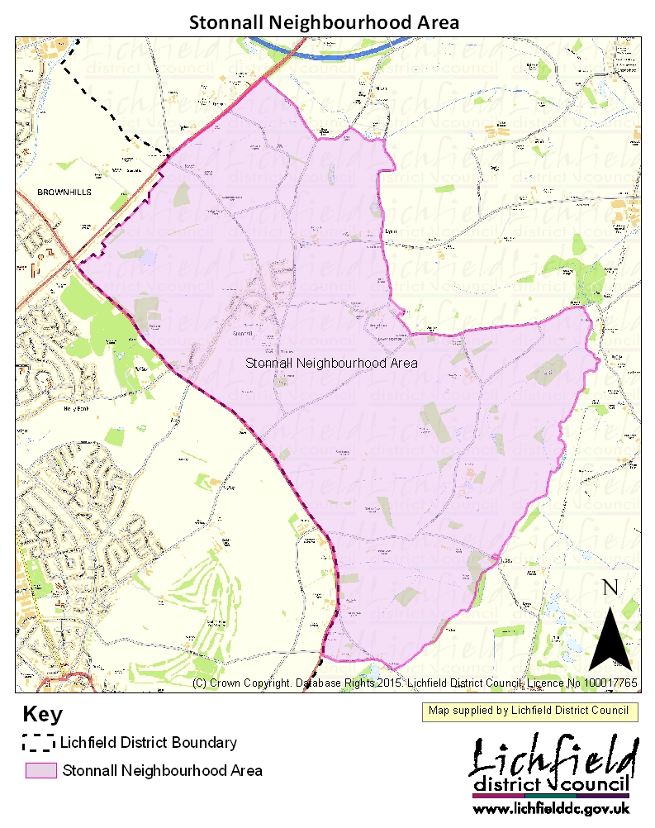

1.4 How the Plan is organised
The Plan is divided into the following sections:

Section 2: The methodology underpinning the development of the Neighbourhood Plan including why the Stonnall area needs a neighbourhood plan and its vision and objectives.

Section 3: offers a brief description of the Neighbourhood Area and main settlement.

Section 4: outlines the policy context at both a national and local level to which this Neighbourhood Plan has paid due regard.

Sections 5-13: The Neighbourhood Plan Policies and their justification. The policies are set out by topic with each policy being followed by a summary of the key findings, the evidence base and issues the local community has raised during the consultation process.

Section 14: Delivering the Plan, sets out: how the plan and its actions will be delivered and an action plan of activities.

A glossary is available at Appendix A of this document explaining the technical terms used in this plan. There is also a large amount of background information which has informed the production of the Plan and this is provided separately.

1.5 Next steps
This document is a consultation draft of the Neighbourhood Plan. Shenstone Parish Council is now asking local people, the District Council, other statutory service providers and organisations for their views on the Plan through a formal public consultation called Pre-Submission (Regulation 14) Consultation.

The comments received will be considered, and the draft Neighbourhood Plan amended to produce a final version. The final version along with its supporting documents will be submitted to Lichfield District Council (Regulation 15). The District Council will then undertake further public consultation on the proposed plan (known as Submission Stage (Regulation 16) Consultation) and then arrange for its independent examination. The independent examiner can only consider whether the submitted Neighbourhood Plan meets the five basic conditions set out by law (see section 1.2 above). Following examination, the independent examiner will issue a report to the local authority. If the plan meets the basic conditions, and if the examiner considers it necessary, the Plan may proceed to a referendum (if a referendum is not considered necessary then the plan can be made immediately). Further modifications to the plan may be suggested by the examiner to ensure it meets the basic conditions before it can proceed to the referendum/be made. It is the responsibility of the local authority to make such modifications and for these modifications to be agreed by the Parish Council.

2.0 THE METHODOLOGY

2.1 Why does the Stonnall area need a Neighbourhood Plan?
The area surrounding Stonnall is predominantly rural and set within the green belt. Its geographical setting can be viewed as both a constraint and an opportunity. The community of the Stonnall Neighbourhood Area is part of Lichfield District and situated in south east Staffordshire on the edge of the Birmingham and Black Country conurbation. Its location within Lichfield District and the presence of ‘A’ roads to the north west and south west of the Ward help to protect it from coalescence with neighbouring urban areas. This gives the community the opportunity to retain its identity and way of life, however due to the proximity of the conurbation the community considers itself as extremely vulnerable.

Stonnall village has seen some services removed in recent years including most notably the loss of the post office. It therefore cannot be assumed that retaining the status quo will necessarily maintain the present quality of life for the community of Stonnall Neighbourhood Area.

This Neighbourhood Plan deals with the designated Stonnall Neighbourhood Area however it is inevitable that much of the Plan will deal with the village of Stonnall where the highest concentration of people and issues reside. This plan will be the principal means by which change can be managed in a way that delivers a sustainable future for the residents and businesses of the Neighbourhood Area.

2.2 How the Plan has been prepared
The Neighbourhood Plan has been prepared for Shenstone Parish Council (the ‘Qualifying Body’ under the Neighbourhood Planning Regulations).

The Stonnall Strategy Group which undertook the work on the original Stonnall Neighbourhood Plan was re-formed in August 2024. As before, it comprised local residents who are active in the community, members of local organisations and parish, district and county councillors. Their task was to re-fresh the original Neighbourhood Plan in light of the fact that Lichfield District Council is in the process of updating its Local Plan.

The Neighbourhood Area chosen for the Neighbourhood Plan is an area within Shenstone Parish and based on the 2013 Ward structure. The Stonnall Neighbourhood Area was designated on 19th February 2013 and shown in section 1.3 above. The original Stonnall Ward boundary changed in May 2015 and amalgamated with Little Aston. As the Stonnall Neighbourhood Area was designated on the original ‘ward’ boundary there is no overlap with adjacent neighbourhood areas.

The revision of the original Plan has been developed taking into account substantial amounts of evidence and the responses and views expressed by the Neighbourhood Area residents. A public meeting was held in September 2024, various follow up meetings and surveys in October 2024 and a Housing Needs Survey and General Questionnaire in December 2024. A Public Consultation day was held in January 2025 where respondents gave significant feedback to shape the final draft of the plan.

The public meetings, surveys and questionnaires demonstrate the breadth of engagement and how the issues have been taken forward to produce the Objectives, Policies and Actions.

2.3 The Vision for the Neighbourhood Plan
The overarching vision for the Stonnall Neighbourhood Area is to:

- create a sustainable, flourishing Ward that provides a high quality of life for all its residents

- create a Ward with a high quality built and natural environment with protection for important historic and environmental assets.

- retain the Ward’s rural identity and independence from neighbouring urban areas.

2.4 The Aims of the Neighbourhood Plan
The ‘Our Village’ document produced as a result of a public meeting in June 2011 presented 10 challenges facing the village. A number of these issues subsequently emerged from the work in developing the original 2016 neighbourhood plan consultation. In addition, some new topics of concern emerged from the various consultations in 2024/25 and were used to inform the aims of the re-fresh of the neighbourhood plan. The aims are summarised as follows:

Housing
- To maintain a sustainable village a balanced age range is required and housing for young and old is needed.

Design
- To secure high quality design of all future development within the plan area.

Local Services
- Address the range and viability of Stonnall Neighbourhood Area’s shops and services including the need/demand for a Post Office, chemist and café etc where viable.

Transport
- Address the issue of commuter traffic in the Neighbourhood Area using Stonnall as a ‘rat run’ Improve the quality and frequency of public transport linkages and enhance the pedestrian experience to include better public rights of way and footpaths.
- Address existing traffic speed and safety issues and introduce appropriate traffic calming measures.

Environment and green spaces
- Protect and enhance the Neighbourhood Area’s trees, woodlands, hedgerows and countryside and culverts.
- Maximise the potential for wildlife and biodiversity to thrive alongside built development.
- Protect green open spaces of value.

Historic Environment
- Preserve and enhance the village character and distinctiveness, buildings and features.

Communication
- Improve communications throughout the Village and surrounding hamlets.

Health Care
- Ensure accessibility to health care.

Community Facilities
- Ensure the community facilities address the needs of the Neighbourhood Area’s residents throughout the plan period.

Community Groups
- Recognising that Village Groups are the lifeblood of the community, help to encourage new groups as well as ensure existing ones flourish for the benefit of all.

3.0 ABOUT STONNALL NEIGHBOURHOOD AREA

3.1 Setting
Stonnall Neighbourhood Area is principally rural and set on the southern boundary of Lichfield District. It is predominantly farmland with one main settlement, Stonnall village and a number of much smaller outlying hamlets.

The Neighbourhood Area is part of the larger Parish of Shenstone and sits in a farmland setting adjacent to both the A452 Chester Road and the A461 Walsall Road.

Stonnall is the largest of a group of ‘smaller’ villages within Lichfield District inset into the green belt.

3.2 Our History
The Neighbourhood Area has remained mostly rural throughout history. It was heavily wooded until at least the Bronze Age, when some clearance may have started to support a small scale pastoral economy. The landscape however only supported minimal human occupation between the Bronze Age and the early medieval period. In the post medieval period the area especially to the north of Stonnall village developed its own field system, with piecemeal enclosure formalised by planned enclosure during the 18th and 19th centuries. During the second half of the 20th century the field systems which emerged during the late medieval period have generally experienced field boundary removal in response to an increased demand for agricultural productivity.

The village of Stonnall has seen considerable expansion in the second half of the 20th century. Stonnall village evolved from a small linear settlement along Main Street and a hamlet at Lazy Hill which was consolidated into a single village through the development of modern housing estates most notably between the 1960s and 1980s.

Within the Neighbourhood Area there are two smaller settlements, namely Lower Stonnall, a dispersed settlement, and representing the lower end of the valley and Lynn located between Shenstone and Stonnall village.

Stonnall village does not have a designated Conservation Area, however the Neighbourhood Area does contain 13 Grade II listed properties and a number of locally interesting features. These are shown on Map A.

3.3 Stonnall Neighbourhood Area Today
Stonnall village has a good range of facilities for its size including a primary school, church, village hall, community centre and two pubs. There is also a football pitch, play area and cricket field further away along the Chester Road. The retail offer is reasonable with a small local centre providing a newsagent/local store, a second general store, tattoo parlour, fish and chip shop, Indian restaurant and a hairdressers. There are also retail facilities on the Chester Road on the edge of the Neighbourhood Area which includes a petrol station, a Floor materials supplier, Indian restaurant and a plant nursery.

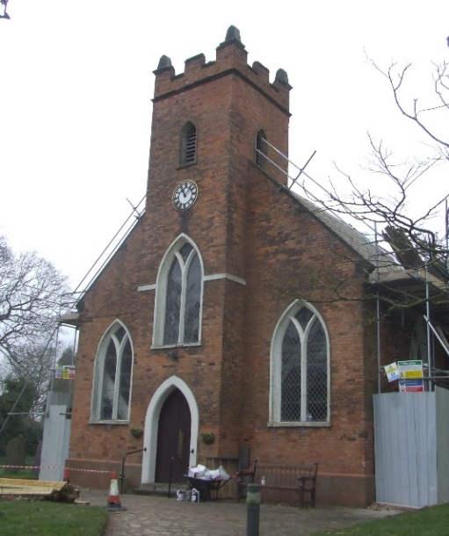
The Neighbourhood Area presents a well-kept and affluent image. The majority of employment age residents in Stonnall Neighbourhood Area are highly qualified professionals, senior executives and business owners. There is however a high percentage of older residents within the Neighbourhood Area as demonstrated in Table 1 below, with only 55% of residents being economically active.

Over 55% of houses are owned outright with 32% being owned with a mortgage with the remainder being shared ownership or rented.

The residents of Stonnall Neighbourhood Area generally enjoy good health with 82% of people stating they are in very good or good health.

Table 1
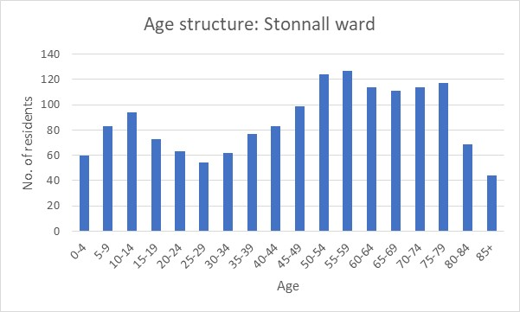
Source: 2021 Census

4.0 POLICY CONTEXT
This Section sets out the key documents with which the Neighbourhood Plan needs to accord.

4.1 National Planning Policy Framework
The National Planning Policy Framework (NPPF) published in December 2024 sets out the Government’s approach to sustainable development. At the heart of the NPPF is the ‘presumption in favour of sustainable development’. Essentially, it is about positive growth with economic, social and environmental gains being sought simultaneously through the planning system. The NPPF is supported by the national Planning Practice Guidance (PPG) an accessible web based resource which is actively managed and updated as necessary.

Neighbourhood Planning forms part of the NPPF legislation, to allow local communities to shape sustainable development within their area and to enable local communities to address their strategic needs and priorities. A Neighbourhood Plan must be in general conformity with the strategic policies of the Local Plan and plan positively to support these policies.

4.2 Lichfield District Local Plan: Our Strategy (2008-2029)
The Local Plan Strategy for Lichfield District provides the broad policy framework and establishes a long term strategy to manage development, provide services, deliver infrastructure and create sustainable communities. The spatial strategy sets out the overall approach towards providing for new homes, jobs, infrastructure and community facilities to 2029 and outlines the broad approach that will be followed towards managing change in the District.

A review of the Local Plan was commenced in late-2024. This new Local Plan will cover the period to 2043, being the same period as the Neighbourhood Plan Review. It is expected that the new Local Plan will be adopted in early 2027.

5.0 HOUSING

5.1 Policy H1
Policy H1: Infill housing development
Infill housing development within the village boundary (as shown on Map A) that meets local need and does not harm the character and setting of the Village will be permitted. The design of development should comply with the principles outlined in the Stonnall Design Guide and the Lichfield District Design Code Supplementary Planning Guidance document (see Policy D1).

5.1.1 Evidence
The amount, location and affordability of new housing in the Neighbourhood Area to 2029 are key policy areas in the adopted Lichfield Local Plan. The adopted Local Plan does not allocate any housing sites in Stonnall however there is the possibility that sites could be allocated by the emerging Local Plan Review. However, the requirement for particular types of new housing to serve the needs in Stonnall remains.

The adopted Local Plan has identified that ‘smaller villages will only deliver housing to accommodate local needs’. Around 5% of the District’s housing (a minimum of 500 dwellings) will be met within village boundaries of these smaller villages, through the conversion of existing buildings, and to meet identified local needs on rural exception sites. The approach in the Local Plan Review – which could range from continuing the same approach to allocating sites for larger scale development – is not known at this stage. However, the 2024 Lichfield Strategic Housing Availability Assessment did not identify any sites as developable within the Stonnall Neighborhood Area. Many of the sites put forward for consideration are within the green belt and therefore protected from development unless the green belt boundaries are changed as part of the Local Plan Review.

5.1.2 You told us
Stonnall Neighbourhood Area’s residents wish to retain the rural feel and setting of the area and the main future concern is large scale and inappropriate housing development, not in keeping with the village. Concern was also expressed about the loss of Stonnall’s identity due to development amalgamating the village with larger neighbouring urban areas. During the consultation process the majority of people who responded would only consider ‘infill’ development when asked about the best location for new housing in Stonnall.
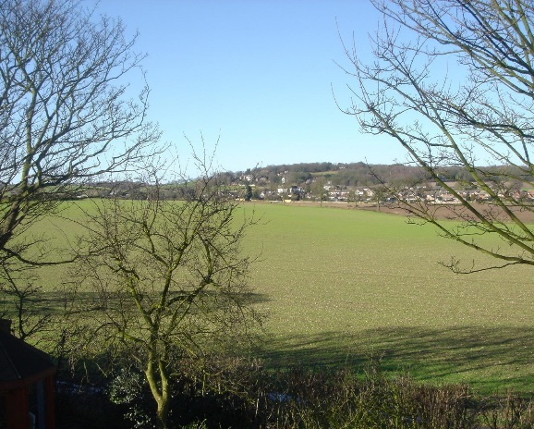

5.2 Policy H2
Policy H2: Rural exception sites
Proposals for small scale affordable housing development on exception sites in the Plan area will be supported subject to the following criteria:
- the proposed development meets the requirements of Policy H2 of the Lichfield Local Plan; and
- the proposed development has due regard to the character of the surrounding area and complies with the principles outlined in the Stonnall Design Guide and the Lichfield District Design Code Supplementary Planning Guidance document (see Policy D1).

All resulting affordable housing units will be required to demonstrate that they comply with a local lettings plan which has been developed in accordance with Lichfield District Council’s Allocation Policy.

5.2.1 Evidence
To enable affordable housing to be provided to meet local housing needs, the National Planning Policy Framework (NPPF) allows new affordable housing to be permitted on small sites in or outside, but adjoining existing village boundaries (known as ‘rural exception sites’). It also states that it is for the local authority to decide whether some market housing should be permitted to facilitate the provision of affordable housing needs of the local community.

Currently only 6% of houses in Stonnall Neighbourhood Area are socially rented. Evidence to inform the 2016 Neighbourhood Plan identified that there was a need for affordable housing in rural areas of the district to meet locally generated need and recommended the delivery of smaller properties (predominantly 2 and 3 bedrooms) and housing with care to cater for both smaller household sizes and an ageing population. More recent evidence, in the Lichfield District Housing and Economic Development Needs Assessment Update 2020, comes to the same conclusion for Lichfield district as a whole, albeit recognising that there was also an important need for 1 bedroom properties as well.

In the 2011 Economic Strategy one of the three weaknesses identified as barriers to business which could apply to Stonnall Neighbourhood Area was housing affordability. It identifies that a desired outcome to address this issue would be an increased balanced supply of housing of different types and tenures with appropriate prices, affordable to the maximum amount of people. Whilst this evidence is now relatively dated, the issue still remains.

Policy H2 sets out to ensure that affordable housing delivers housing to meet local needs. Compliance with a local lettings plan will ensure that new affordable rented homes are allocated to people in need and with a local connection to the neighbourhood plan area.

5.2.2 You told us
The majority of residents (63%) considered that their current property would still meet their needs in 10 years’ time. However, 31% of people living in the Stonnall Neighbourhood Area consider that the area does not have the type of property to meet their future needs. With the ageing population, it is likely that these needs relate to housing suitable for older people. to set up a household in Stonnall in the near future and would probably be renting from a social landlord or through shared ownership/equity.

To ensure the sustainability of the village it was considered by a number of people that a good age range including young families as well as older people is necessary and consequently affordable homes/ homes to house this age range are required.

5.3 Policy H3
Policy H3: Housing to support the needs of older people
Support will be given to development that provides well designed homes which are either adapted to meet the needs of older people or are easily capable of adaptation.

5.3.1 Evidence
The Ministry of Housing, Communities and Local Government measures ten key indicators to determine what level of deprivation people are facing in local areas. The Index of Multiple Deprivation indicates Stonnall Neighbourhood Area falls within the top 20% of least deprived areas with England. However Stonnall Neighbourhood Area scored poorly on ‘Barriers to Housing’ and falls within the bottom third nationally with regards to this domain.

At 29%, Stonnall Neighbourhood Area has a higher percentage of residents aged 65 and over when compared to the statistics for the West Midlands (19%) and England (18%). Of those responding to the Neighbourhood Plan Housing Survey, 32% live in a household as a couple where both occupants are aged over 65.

There is a need not only for a range of housing, particularly smaller dwellings, but housing that is capable of addressing the needs of the community as people age. Local estate agents reported that whilst 3-bed semi-detached properties are very popular, so are bungalows for older people looking to downsize. The limited number of properties in Stonnall means that when properties do come on the market, they sell very quickly.

5.3.2 You told us
98% of respondents to the Housing Survey live in a detached, semi-detached house or a bungalow, with 94% of respondents stating that their property meets their current needs. For those who expressed a wish to move in the future, there was a split of those wanting larger or smaller accommodation; the desire to move appears to be linked more to the type of housing rather than the size. This follows the evidence from local estate agents, with the greatest demand being for both 3-bed semi-detached properties and smaller bungalows.

6.0 DESIGN

6.1 Policy D1
Policy D1: Design and character
Development in Stonnall is expected to preserve and, where possible, enhance the character and setting of the village (unless located well outside the village boundary). Development must demonstrate how it has been informed by the Stonnall Design Guide and the Lichfield District Design Code Supplementary Planning Guidance document.

6.1.1 Evidence
Stonnall village itself evolved from a small linear settlement and a hamlet at Lazy Hill which was consolidated into a single village through the development of modern housing estates most notably between the 1960s and 1980s. Perhaps as a result of this, there is little by way of built heritage in Stonnall. There is also no Conservation Area and only few listed buildings throughout the Neighbourhood Area. However, this is not to say that Stonnall does not have its own character, part of which is reflected through its built structures and form.

A short design guide has been prepared to help development in Stonnall to ensure that it is of high quality and reflects the character of the village and its rural surroundings (see Appendix B). This addresses matters such as the layout of frontages to properties, building heights, roof pitch and materials. It complements the Lichfield District Design Code Supplementary Planning Guidance document.

6.1.2 You told us
Future concerns which emerged through the consultations centred around the protection of the village ethos, and the surrounding countryside. Notwithstanding wider concerns about the perceived threat of large scale housing being imposed on Stonnall, it was recognised that there would be small scale housing development, often in the form of ‘infill’ development, over the plan period. Indeed, if more of the housing needed by the community is to be provided then this will be important. What is equally important is the need to ensure that development reflects the character of Stonnall and represents high quality design.

7.0 TRANSPORT

7.1 Policy T1
Policy T1: Cycling and walking
Planning permission will be granted for new or improved cycling or pedestrian access to facilities and services providing that they take account of the residential amenity of adjacent properties and do not otherwise affect the safe flow of traffic on the highway network.

7.1.1 Evidence
The NPPF encourages plans to take opportunities to promote walking, cycling and public transport, giving people real choice about how they travel.

Insofar as planning permission may be required for the range of such facilities that may come forward in the plan period, Policy T1 sets out a positive context for their determination. In assessing the suitability of proposals that require planning permission the policy sets out the importance of safeguarding the residential amenities of residential properties that may be affected, and the integrity and safety of the wider highway network.

The Local Plan Strategy is based around sustainable movement. Core Policy 3 specifically refers to reducing the overall need for travel whilst optimising choice of sustainable modes of travel particularly walking, cycling and public transport, whilst Core Policy 5 supports initiatives related to sustainable transport improvements within the District. Policy ST1 of the Local Plan also supports measures and specific schemes to improve services and facilities for non-car based travel.

One of the aims of the Staffordshire Local Transport Plan 2011 is to get more people walking and cycling and Policy 6.1: ‘We will create a physical and cultural environment in which everyone feels confident to walk and cycle’ will be delivered through the Staffordshire Local Cycling and Walking Infrastructure Plans.

7.1.2 You told us
A number of people noted that the public rights of way need to be better maintained (including lighting in appropriate locations) with improved access for all (where possible) and signage of bridlepaths. Maintenance of pavements and the lack of pavement between Stonnall, Lynn and Shenstone were also highlighted, with improvements to the cycle paths around the village important to a number of respondents.

Stonnall Neighbourhood Area residents appear to want to be independent from surrounding areas and do not feel the need to interact with other settlements on a daily basis, hence the need for an improved offer of shops, their range of services and a post office. It is therefore important that accessibility within the ward allows access to services in a sustainable manner.

8.0 BETTER LOCAL SHOPS

8.1 Policy LSH1
Policy LSH1: Improving local retail
Planning permission will be granted for proposals that seek to extend the range of facilities offered from the existing retail units identified on Map A.

Planning permission will be granted for the use of the retail units along Main Street for business, services and other facilities subject to the following criteria:

- the proposed uses enhance local provision; and
- the proposed uses do not detract from the vitality and viability of the Main Street retail centre.

8.1.1 Evidence
The retail offer within Stonnall Village, located on Main Street, currently includes two pubs, a newsagents/local store, a second general store, fish and chip shop, Indian restaurant, tattoo parlour and a hairdressers. Additional services within the Ward can also be found on the Chester Road, and includes a petrol station, Indian restaurant, floor outlet and plant nursery.

The NPPF section ‘Supporting a prosperous rural economy’ recommends promoting the retention and development of accessible local services and community facilities, including local shops.

The Local Plan Strategy Core Policy 3 specifically refers to protecting the amenity of residents and seeking to improve their overall quality of life through the provision of appropriate infrastructure, services and facilities.

Policy LSH1 recognises the importance of the retail units on Main Street to the sustainability of the village. The policy provides support for any planning applications that may be required to extend the range of facilities on offer in the individual units. The policy also offers support for the introduction of other facilities subject to criteria. The introduction of a post office and chemist/pharmacy facilities into the units on Main Street would be positively encouraged and supported.

8.1.2 You told us
Stonnall Neighbourhood Area residents appear to want to be independent from surrounding areas and do not feel the need to interact with other settlements on a daily basis, hence the need for improved offer of shops, their range of services and a post office.

The most well used shops in the Ward are the Premier convenience store which is used by virtually all respondents and the fish and chip shop, both of which are located in the parade of shops on Main Street. There is no longer a post office in Stonnall although the community would be very keen to see such a facility return. Residents now have to travel to a variety of locations but most notably to Lazy Hill and Shenstone to access post office services. 80% of respondents said that a wider range of shops was required in Stonnall Village and suggested shops including a chemist and a café.

8.2 Policy LSH2
Policy LSH2: Stonnall Village shops – environmental improvements
Environmental improvements to ensure the vitality and viability of the Stonnall shops will be supported.

8.2.1 Evidence
The parade of shops in Stonnall Village is a typical 1960’s development with residential apartments above. The rear elevation facing the Playing Fields would benefit from some general improvements to its appearance.

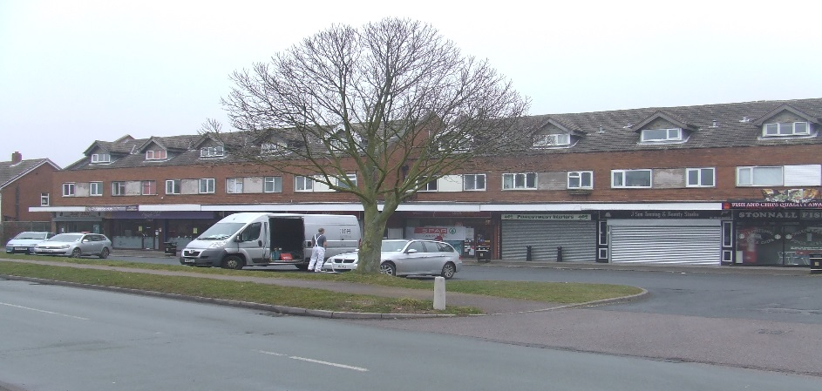

8.2.2 You told us
Several comments were received relating to a poor variety of shops and the need for a post office and chemist. A number of comments received from residents also considered that the flats above the shops need facelift improvements to their front and rear elevations. The forecourt parking area needs a general tidy up and updating to include properly laid out car parking spaces.

9.0 HEALTH CARE

9.1 Policy HC1
Policy HC1: Healthcare provision
Improvements to existing healthcare provision and infrastructure within the village will be supported, including infrastructure which enables mobile services that support healthcare.

9.1.1 Evidence
None of Lichfield District’s population live in the 20% most deprived areas in England for health deprivation and disability. From the ONS Census data 2021, 82% of people in Stonnall Neighbourhood Area state they are in very good or good health, with only 3.4% in bad or very bad health This is less than the District and National figures of 5.2% and 5.7% respectively.

Core Policy 10 of the Local Plan is concerned with Healthy and Safe Lifestyles and where appropriate the District Council will support the development of new or improved facilities and initiatives which contribute to improved and accessible local healthcare.

9.1.2 You told us
Stonnall Village does have a GP surgery, however only 25% of respondents to the survey use this surgery. The reasons behind alternative GP surgeries being used were:
- An inability to get an appointment Impractical opening hours/perception of opening hours
- Other local GP surgeries offer a wider range of services.

A number of people highlighted that the provision of a chemists locally would significantly improve the medical service offer.

10.0 BETTER LOCAL COMMUNITY FACILITIES

10.1 Policy CF1
Policy CF1: Improvement of community facilities
The Plan supports proposals for the enhancement or adaptation of indoor community spaces to provide for a wider range of community needs.

10.1.1 Evidence
There is a particular need to ensure that existing facilities are able to adapt or are appropriately replaced to ensure the level of existing capacity is maintained and able to grow with demand for the length of the plan period.

The previously named Youth and Community Education Centre, changed to become The Stonnall Community Centre in 2022 and is constituted as a Charitable Incorporated Organisation. In terms of construction it is a temporary style building made mostly of wood with some steel framing. It remains likely that without significant investment the infrastructure will continue to fail in the coming years. The current space restricts the type of activities it can host, which is currently pre-dominantly used by small Community Groups. The Trustees are looking into the feasibility of raising funds to re-build this centre.

The second public building is The Stonnall Village Hall operated as a Charitable Trust which is a purpose built brick and tile structure. It is mostly used again by Village Groups, Parties and Weddings but also hosts commercial use such as Weight Watchers, Pilates etc. It is currently oversubscribed for evening functions. In addition the current space is unable to adapt and accommodate dual or multiple use.

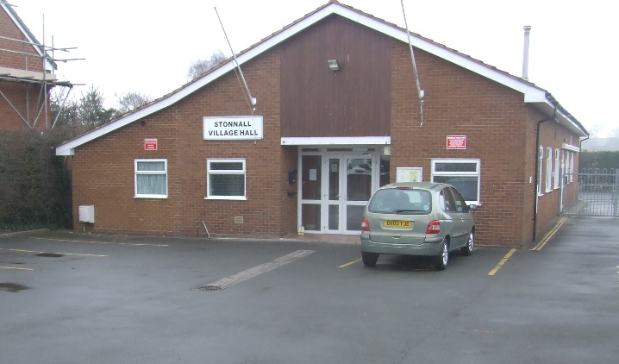

Policy CF1 provides a context to support proposals for the enhancement or extension of existing community facilities insofar as they may need planning permission. The Plan is particularly keen to promote the development of flexible community facilities which meet the needs of all its residents.

10.1.2 You told us
Stonnall Neighbourhood Area is renowned for having a large number of active community groups. The Community Survey identified that 20% of respondents consider there is a need for improvements. In particular they referenced youth provision and the range of offer that can be accommodated. .

10.2 Policy CF2
Policy CF2: Stonnall Playing Fields
Stonnall Playing Fields as identified on Map A will be protected from residential and other development for the benefit of the community of Stonnall.

Improvements to the range and quality of equipped play facilities and additional infrastructure to facilitate the greater use of the playing pitches located at Stonnall Playing Fields will be supported.

10.2.1 Evidence
According to the Open Space Assessment 2024, Stonnall has three amenity green spaces with the largest site being located around the playing fields at Stonnall. Stonnall village has complete coverage within a 480m/10-minute walk time catchment despite the linear form of the settlement. Stonnall Playing Fields is the largest amenity open space, centrally located and easily accessible to most of the village. It contains a football pitch in the centre, a children's playground and a small skateboard facility. It is also used as a focal point for outdoor gatherings and Village shows and fetes etc.

Further out of The Village some two miles along The Chester Road there is another Sports Field that is in control of Four Oaks Football Academy and is almost entirely used for their activities of football and also cricket use too.

The Lichfield Open Space Assessment 2024 highlights that Stonnall play area has had little investment over recent years . Also, the range of equipment in terms of its value in providing play for young children needs to be considered alongside the general physical quality of the play area.

The Lichfield Playing Pitch Strategy 2020 identifies in Stonnall Neighbourhood Area, the football provision is at capacity, largely due to the poor quality of the pitches. Improvements to the existing pitch on the Playing Fields are therefore seen as a local priority. Changing rooms would however enable the Playing Fields to be more widely used.

The Lichfield Playing Pitch Strategy 2020 also identifies Mill Green Recreation Ground which is located within Stonnall Neighbourhood Area. The study notes that there is scope to further expand and improve Mill Green Recreation Ground in terms of football and cricket provision.

10.2.2 You told us
The Playing Fields are valued (over 80% of respondents to the Community Survey actively said that they used and valued it) and it was noted that they were generally well maintained and well used. Suggestions for improvements included lighting and adding toilets/changing facilities . Some respondents would like the play facilities upgraded. The play area was identified as being well used, with the facilities considered to be adequate although would benefit from being modernised and improved.

10.3 Policy CF3
Policy CF3: Community gardens and allotments
New community garden areas and allotments within or in very close proximity to the village boundary of Stonnall will be supported providing the proposals protect residential amenity and do not detrimentally impact on the flow of traffic on the highway network or the safety of pedestrians.

10.3.1 Evidence

Natural England recognises the importance of green infrastructure which can provide many social, economic and environmental benefits close to where people live and work including local food production through allotments and gardens. The Local Plan Strategy Core Policy 10 also supports initiatives such as allotments to enable access to healthy food.

Policy CF5 sets out a positive context for the consideration of proposals for new such facilities. A later section of the Plan sets out support for other initiatives to encourage the long term take up of allotment plots.
The Diamond Jubilee Allotments which contain around 45 plots were opened in early 2012 and are located on Cartersfield Lane just outside Stonnall Village. The Jubilee Allotments membership has a website and appears to have a very active community with few current vacancies. Proposals to provide more allotments are therefore supported. Alternatives to allotments – which are often located on the edges of settlements - are community gardens. These are normally much smaller than allotments but are located in the heart of communities where people can easily access them and share growing activities together.

10.3.2 You told us
Only 19 people commented on the allotments in the questionnaire survey undertaken in 2013. However, in the 2024 Community Survey over 100 people felt that the allotments were an important and valued part of life in Stonnall.

11.0 HISTORIC ENVIRONMENT

11.1 Policy HB1

Policy HB1: Listed buildings and structures
Heritage assets within the Neighbourhood Area (especially listed buildings and buildings or structures on the Local List) and their settings must be protected, conserved and enhanced when development proposals are brought forward.

In assessing proposals which involve the loss or alteration of a building or structure on the Local List, consideration will be given to:
- whether the asset is structurally unsound and beyond feasible and viable repair (for reasons other than deliberate damage or neglect); or
- the extent to which measures to sustain the existing use, or find an alternative use/user, have been investigated.

Where a development proposal would result in the loss of, or harm to a building or structure on the Local List, a balanced judgement will be made as to the acceptability of the proposal having regard to the scale of any harm or loss and the significance of the heritage asset.

11.1.1 Evidence
Historic England identifies that local lists play an essential role in building and reinforcing a sense of local character and distinctiveness in the historic environment. They provide a unique opportunity for communities, in partnership with local authorities, to identify heritage assets that they wish to protect at the local level.

The value of locally listed buildings is also recognised in Policy 14 of the Local Plan Strategy.

Stonnall village itself does not have a designated Conservation Area, however it does contain 13 Grade II listed properties and a number of buildings/structures of interest from a variety of periods which help to create the village character and are worthy of local listing (on the Lichfield District Council Local List). One example is the remnant of a black and white fingerpost outside Ivy Cottage.

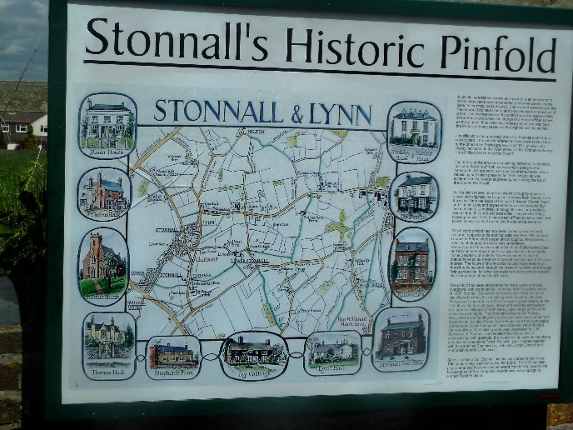

11.1.2 You told us
96% of responses to the Community Survey referred to the need to preserve the village’s identity including its surrounding countryside.

Respondents articulated a wish to preserve and retain village character, buildings and features. Concern was expressed over the loss of Stonnall’s identity due to development amalgamating the village with larger urban towns, and retaining and investing in historic buildings.

11.2 Policy HB2
Policy HB2: Historic farmsteads and agricultural buildings
Redevelopment, alteration or extension of historic farmsteads and agricultural buildings within the Neighbourhood Area should be sensitive to their distinctive character, materials and form. Due reference and consideration should be made to the Staffordshire Farmstead Assessment Framework.

11.2.1 Evidence
Farmsteads, and in particular traditional farm buildings of 19th century or earlier date make a fundamental contribution to local distinctiveness and a sense of place, through their varied forms, use of materials and the way they relate to the surrounding form and patterning of landscape and settlement. The majority of the field systems across the character area exhibit a morphology which suggests they were enclosed as planned enclosure during the 18th/19th century which corresponds to the development of traditional farm buildings.

The ‘Historic Farmsteads And Landscape Character in Staffordshire’ 2012 report for Staffordshire County Council and English Heritage identifies that in Lichfield District there are high rates of survival with 78.8% of historic farmstead sites retaining some working buildings with a higher proportion of farmsteads in residential use than is typical of the region as a whole and a slightly lower proportion in agricultural use. Whilst some will likely have been lost since this time, there are still a significant number worthy of protection.

11.2.2 You told us
The rural atmosphere is the most valued element of this Neighbourhood Area. Respondents value the quietness of the village and easy access to the countryside from being in a rural location. It was also identified that the loss of historic buildings could destroy the nature of the village and residents wanted to see the preservation and retention of the village character, buildings and features.

11.3 Policy HB3
Policy HB3: Archaeology
Development must take account of known surface and subsurface archaeology and ensure unknown and potentially significant deposits are identified and appropriately considered during development. Lack of evidence of subsurface archaeology must not be taken as proof of absence and in all instances the Staffordshire Historic Environment Record should be consulted at an early stage in the formulation of proposals.

11.3.1 Evidence
The current understanding of the earliest landscape of this Historic Area Character Area (HECA) in which Stonnall Neighbourhood Area resides, suggests that the majority had been heavily wooded until at least the Bronze Age, when some clearance may have started to support a small scale pastoral economy. By the later 11th century this Character Area probably formed part of the Royal Forest of Cannock dominated by a mix of woodland and heath land which may suggest that the landscape supported only minimal human occupation in the centuries between the Bronze Age and the early medieval period.

Evidence of possible Roman and later settlement lies near Hilton. There is high potential for unknown archaeological sites to lie in the northern part of the HECA, which perhaps relates to activity at Wall during the Roman period.

12.0 LANDSCAPE AND ENVIRONMENT

12.1 Policy LE1
Policy LE1: Wildlife-friendly development

All development proposals should aim to protect existing habitats and species, including hedgerows and mature trees. In particular, developments required to deliver measurable biodiversity net gain (a minimum of 10%) and that require the removal or reduction of existing habitats will be expected to deliver biodiversity net gain on site.

The incorporation of design features into new development that encourages local wildlife and biodiversity to thrive will be supported.

As appropriate to their scale, nature and location, development proposals should be designed to retain trees, shrubs and hedgerows of arboricultural, habitat and amenity value on-site. Where it has been clearly demonstrated that there are no reasonable alternatives to the removal of one or more mature trees, direct replacements of appropriate tree species should, where possible, be planted on the same site. Where practicable, any new planting should consist of species of trees, hedging, shrubs and grasses that will be resilient to climate change and can be incorporated in a way that would ensure they provide a habitat that allows wildlife to thrive.

12.1.1 Evidence
There are no statutorily protected nature conservation sites within the plan area there are a number of Biodiversity Action Plan (BAP) habitats including deciduous woodland near New Barns Farm, Forge Wood, Mill Farm and Fishpond Cottages. There is also floodplain grazing marsh habitat on the Footherley Brook. Just across the parish boundary there is the Shire Oak Local Nature Reserve (LNR) and the Castle Bank Plantation Local Wildlife Site. Any proposals or projects that may be considered during the Neighbourhood Plan process would need to take these sites into account.

Core Policy 13 of the Local Plan Strategy supports the safeguarding of the District’s ecological networks.

The Staffordshire Biodiversity Action Plan (SBAP) identifies Ecosystem Action Plans (EAP) and Stonnall Neighbourhood Area falls within the Central Farmland EAP. The primary objective for the Central Farmland EAP is to reduce fragmentation of existing semi-natural habitats by linking sites through the creation of habitat corridors and networks using hedgerows, arable field margins and rivers where possible.

The design of individual buildings and of neighbourhood scale green and open spaces, including private gardens, will help to ensure that existing habitats present in Stonnall can thrive and a range of new habitats can be created. This is in line with the requirement of the Environment Act 2021 for all new development (excluding small householder proposals) to achieve net biodiversity gain of at least 10%.

Planting is an important aspect of development and habitat creation. Not only does a well-considered planting scheme provide high quality landscaping, it is also a fundamental aspect of enhancing biodiversity that otherwise would be lost. Planting schemes should ensure that tree species should be carefully selected to be responsive to landscape and historic character and to suit the planting location. Planting should not simply consist of trees but a range of shrubs and grasses too and should seek to include native species.

Protecting species present in the area is also important. Examples of the simple solutions that well-thought out design could easily incorporate are:
- Integral bird and bat boxes under the eaves of the new houses, or artificial nests sited in places away from windows and doors, can create vital new roosting sites to support populations of birds and bats.
- Boundaries between dwellings can be made hedgehog friendly by including pre-cut holes for hedgehogs to more effectively move across neighbourhoods to forage.
- New planting schemes can support bees and other pollinators by including nectar-rich plants.

12.1.2 You told us
The rural atmosphere and natural environment such as trees, woodland and hedgerows are the most valued elements of this Neighbourhood Area. Hedgerows and their retention were seen as an important aspect of village. It is also considered important that trees and woodland are maintained and preserved. Existing wildlife habitats should be preserved and protected for future generations and school children, farmers and landowners encouraged to support wildlife and create new habitats including a wildflower area.

12.2 Policy LE2
Policy LE2: Visually important trees and hedges
Development proposals will be required to retain existing trees and hedgerows of good quality and/or visual significance, trees and hedgerows which are likely to become visually significant when a site is developed or have been identified as being of historic importance. During the course of any development such trees and hedgerows should be protected to ensure their future survival and retention.

12.2.1 Evidence
There are a number of Tree Preservation Orders within the Neighbourhood Area, with individual TPOs on a large proportion of hedgerow trees along roadsides, ‘Area’ TPOs around Lynn Cottage, Shepherds Farm and Heath Close, and ‘Woodland’ TPOS on two areas of woodland between Lynn Lane and the A461. These TPOs are mapped in the Evidence Base V5 document.

Stonnall Neighbourhood Area also falls within the Forest of Mercia boundary. The Forest of Mercia is part of a national programme of ten Community Forests in England developed in the early 1990s and located in and around England’s largest towns and cities.

The field systems have generally experienced field boundary removal during the second half of the 20th century in response to an increased demand for agricultural productivity. Some historic field patterns survive reasonably well to the south and south-east of Stonnall.

Core Policy 13 of the Local Plan Strategy supports the safeguarding of the District’s ecological networks.

Both the Staffordshire Biodiversity Action Plan and Lichfield District’s Biodiversity Strategy aims to prevent further loss of existing and promote the planting of woodlands and hedgerows.

12.2.2 You told us
Hedgerows and their retention are seen as an important aspect of the Neighbourhood Area and it is important that trees, hedgerows and woodland are maintained and preserved.

12.3 Policy LE3
Policy LE3: Green infrastructure and flood mitigation
Development proposals will be required to include the provision of new landscaping and green infrastructure appropriate to the setting and size of development. Development should be sympathetic to the landscape character and quality of the Neighbourhood Area with due reference and consideration made to the Staffordshire Landscape Character Assessment.

Where Sustainable Drainage Systems (SuDS) are required and it is practical to do so, SuDS provision should demonstrate how its design will enhance wildlife and biodiversity as well as minimise the impacts of flooding.

12.3.1 Evidence
Multi-functional green infrastructure can deliver a range of benefits including improved flood risk management, provision of accessible green space, climate change adaptation and biodiversity enhancement. It is a requirement of National Planning Policy Framework paragraph 159 that in planning to avoid increased vulnerability to climate change, risks should be managed through a range of measures including the creation of Green Infrastructure.

Applications which incorporate sustainable drainage systems (SuDS) within their proposals will be particularly welcomed. Often such provision can be made as part of wider green infrastructure provision. The most effective SuDS schemes not only mitigate flood impact but also enhance biodiversity by providing habitat.

12.3.2 You told us
At the Public Consultation day lots of comments were made about flooding. A number of specific locations were identified including Gravelly Lane, Wallheath Lane, Glenwood Rise, Berryfields, Cartersfield Lane and the Chester Road. Flooding across the fields to the Stonnall Playing Fields, into The Culvert and approaching St Peter’s Close, along with flooding of the footpath area, was raised as a concern. Some people mentioned that grass verges are parked on by cars which not only destroys the grass but compacts the ground, thereby making it more difficult for rainwater to soak away.

12.4 Policy LE4
Policy LE4: Cannock Chase Special Area of Conservation
Before development is permitted it must be demonstrated that alone or in combination with other development there will be no adverse effect whether direct or indirect upon the integrity of the Cannock Chase Special Area of Conservation (SAC) having regard to avoidance or mitigation measure.

Any development will be required to mitigate for its own impact and development will not be permitted until satisfactory mitigation measures have been secured.

12.4.1 Evidence

Sitting within the wider AONB, the Cannock Chase SAC was designated in 2005 under the provisions of the European Habitats Directive, the majority of the site having previously been designated as a SSSI in 1987. Cannock Chase represents the largest area of heathland habitat surviving in the English Midlands and though much diminished in area from its original extent, as with all lowland heathland zones, the habitat and dependent species are of very high nature conservation importance. The Annex I habitat, European Dry Heath is the primary reason for designation of the SAC. The character of this vegetation is intermediate between the upland or northern heaths of England and Wales and those of southern counties.

Any residential development which results in a net increase in dwellings within the 15km zone of influence of Cannock Chase Special Area of Conservation (SAC) will be deemed to have an adverse effect on the SAC.

The evidence base (from Footprint Ecology) shows significant impacts from high visitor numbers. Additional visits from the residents of new developments would be expected to increase this impact unless measures to prevent this are put in place. The main impacts are the fragmentation of habitat from a multiplicity of paths and tracks, track and path widening with erosion, trampling and compaction, and eutrophication from dog fouling.

Evidence commissioned by the SAC Partnership suggests that the planned level of growth within a 15 kilometre radius of the SAC is likely to have a significant effect on its condition. The greater part of this effect would arise from development within an 8km zone as it has been determined through research that this zone would contribute the most visitors to the SAC. The effect of increased visitor numbers consists of additional damage from site use and vehicle emissions. In granting planning permissions the Local Planning Authorities must comply with their duty under the Habitats Regulations as a Competent Authority to ensure appropriate mitigation is delivered prior to developments being built and new visits generated.

13.0 SHIRE OAK QUARRY

Shire Oak Quarry has been in existence since 1940 and sits to the west of Stonnall some 250 metres away from the nearest point of the Village.

The land that is being quarried is owned by two local families, together with some land owned by the current operators, JPE Ltd. There have been various operators of the quarry over the years and JPE Ltd took over the existing management from Tarmac Ltd several years ago.

The closeness of the Quarry and given the westerly wind direction, the Village has some disruption in terms of noise and dust pollution. A Quarry Liaison Group has been in existence for several years whose job is to ensure various planning and operational rules are followed as well as generating good relationships with Village residents through various levels of Councillors. The relationship with JPE Shire Oak has prospered in recent years and it has donated considerable sums of monies to various village groups including St Peter’s School.

In recent years JPE Shire Oak has made significant progress in returning the quarry back to nature. An area as big as several football pitches has now been filled and grassed over. Approximately 4,500 trees have been planted throughout the quarry and work continues ahead of current schedule.

It is understood that JPE Shire Oak are likely to have completed their extraction of all minerals by 2028 and will continue with their plans to infill the site and return to its natural farmland state by approximately 2030. However, these timescales are flexible as final completion will depend upon the demand for aggregate coupled with enough suitable inert infill being available from other organisations.

Whilst the future use of the quarry will be determined by the landowners, the community has expressed its wishes as to what it would like to see. At the Public Consultation day there was significant interest in this question. The majority of attendees wished for this to be kept as a nature reserve, with a significant number of other people wanting it to be returned to productive farmland.

It is intended that Stonnall Village, through its various levels of Councillors and the Quarry Liaison Group, will monitor matters going forward and seek to have a role in shaping any future plans with a view to ensuring that Stonnall benefits from whatever opportunities materialise.

14.0 NON LAND USE POLICIES

14.1 Non Land Use Policy 1 – ’Smarter’ travel choices
Non Land Use Policy 1
The Neighbourhood Plan will support the adoption of ‘smarter choice’ travel measures such as workplace travel plans and car clubs, car sharing schemes. It will also work with bus operators to provide improved services.

14.1.1 Evidence
In Lichfield District around 35,000 people (36%) are defined as living in the most disadvantaged quintile nationally for geographical access to services. These are located in a number of Wards throughout the District and include Stonnall Neighbourhood Area along with Little Aston and Shenstone Neighbourhood Areas. The Rural Settlement Sustainabilty Study (2011) scored Stonnall highly in terms of services and facilities within the village despite the post office having closed, but does not score as highly in accessibility due to the lack of a half hourly bus service. Since this time, such services have not been improved.

The Chaserider company operates eleven bus services on the no. 36 route daily from Monday to Friday between Lichfield and Walsall (via Aldridge) which pass through Stonnall and Shenstone. It also operates nine services on Saturdays and Sundays. Commuting to and from Walsall does not appear to be an issue, with the first bus travelling to Walsall passing through Shenstone and Stonnall around 8am, and the last return journey being 18.59pm. Travel to and from Lichfield City however appears to present more of an issue as it either involves taking an earlier bus (at 7.21am) or using the school service to The Friary School in Lichfield, which does not include a stop in the centre of the City.

Stonnall Neighbourhood Area does not have a train service, the nearest stations are located at Shenstone and Blake Street.

Staffordshire County Council has undertaken a highways survey which has shown that the main issue to be addressed is the speed and volume of traffic cutting through Wall and therefore Stonnall to avoid the A5 Wall Island.

14.1.2 You told us
By far the most important issue of sustainability identified by residents is the need for better public transport. In the Community Survey there was a split of people who felt that the bus service had improved since 2014 but the main suggestions for improvements focused on putting on more routes and timetables including more services running both early and late in the day.

The local transport infrastructure is one of the few dislikes residents have about Stonnall. It appears that the infrequent daytime, and very limited evening bus services along with limited routes leads to residents not being able to travel to where the services are located. The post office is identified as the most inaccessible service followed by hospitals and a train station. As such the main mode of transport is overwhelmingly the car. A number of different post offices are now used most notably Shenstone and Lazy Hill, both situated on current bus routes.

14.2 Non Land Use Policy 2 – HGV/LGV traffic
Non Land Use Policy 2
Proposals which improve local and strategic traffic management though routing of HGV/LGV traffic away from the local road network will be supported.

14.2.1 Evidence
Vehicle movement studies undertaken by Staffordshire County Council in 2014 identified that the main issue to be addressed was the speed and volume of traffic cutting through Wall and therefore Stonnall to avoid the A5 Wall Island. Since this time, the community has been very clear in its opinion that such issues have worsened. Whilst The Staffordshire Freight Strategy 2019 identifies that much of the HGV traffic in rural areas has a legitimate right of access to a point of collection or delivery and a significant proportion of it is related to a business operating in the rural area. The small proportion of HGV traffic that is using the rural network inappropriately however is of considerable concern to local communities.

14.2.2 You told us
A significant majority of respondents to the Community Survey specifically referenced concern over the speed of vehicles through Stonnall. A smaller but still significant proportion of people were concerned about HGV traffic using the small rural roads. In particular it appears that HGV’s are cutting through the Ward from the A461 generally via Cartersfield Lane and Lynn Lane to access the Shenstone Industrial Estate and at times are using lanes which are in the opinion of the residents, too narrow for the size and weight of vehicle.

14.3 Non Land Use Policy 3 – Local traffic issues
Non Land Use Policy 3
Support will be given to infrastructure improvements in the Neighbourhood Area, particularly those which address local traffic issues including existing traffic calming, HGV restrictions and commuter traffic.

Stonnall councillors will work with Shenstone Parish Council, Staffordshire County Council and Walsall Metropolitan Borough Council to identify solutions to the traffic issues affecting Stonnall.

The Community Speedwatch programme will be encouraged and supported where possible.

Appropriate support will be given to the Stonnall Community Road safety group (SCAR) to assist with their initiatives to campaign for better road safety for vehicles, pedestrians and all other road users.

14.3.1 Evidence
The Staffordshire Local Transport Plan 2011 acknowledges that transport can have both positive and negative impacts including road traffic injuries, poor air quality and unwelcome noise. It has identified road traffic is the most common source of noise pollution and can contribute to stress-related health problems, and interfere with concentration and sleep. Certain traffic calming features, particularly speed cushions, road humps and those resulting in stopping and acceleration, have led to complaints about the increased noise from road traffic. As such the Local Transport Plan includes Policy 6.5: ‘We will reduce the negative impact of traffic related noise’ and specifically includes ‘designing traffic calming schemes that minimise noise generation such as avoiding features that involve a ‘vertical deflection’ wherever possible.’

The Staffordshire Freight Strategy 2019 acknowledged that HGV’s are particularly unsuited to narrow rural roads and a small proportion is using the rural network inappropriately and is of considerable concern to local communities. There are a number of frequently cited causes of concern (evidenced from the Staffordshire Parish Council Survey (SPCS) and complaints direct to the County Council and include amongst others ‘rat running’ through rural areas to avoid congestion. One action of the Freight Plan is to work with local communities and the freight industry to consider areas for weight restriction on individual merit having particular regard to the impact and quantum of HGV traffic, the sensitivity of the area, the population affected, the level of access required and the availability of suitable alternative routes.

14.3.2 You told us
Whilst volume and speed of traffic (of all kinds) in Stonnall is a major issues for many residents, throughout the consultation process residents expressed their overwhelming dislike of speed humps. People felt that they do not assist in reducing the speed of traffic and cause more pain and inconvenience to locals. Given the concerns with the level of traffic through the village an alternative option such as chicanes was suggested by over one quarter of residents responding to the community survey.

The number of HGVs and their routes through the Ward is also an important issue for residents and suggestions such as a requirement for the imposition of further weight limits and additional weight limit signage were received at the Public Consultation day.

14.4 Non Land Use Policy 4 - Health
Non Land Use Policy 4
Transport services and infrastructure that enables access to a wide range of health services located within and outside the Neighbourhood Plan area will be supported.

14.4.1 Evidence
The Rural Settlement Sustainability Study (2011) noted that Stonnall scores highly in terms of services and facilities within the village despite the post office having recently, but does not score as highly in accessibility due to the lack of a half hourly bus service. Public transport connections are poor and this is reflected by a high car ownership.

Settlements can appear more isolated in terms of their location away from main urban centres or lack of public transport. Even settlements close to some urban areas can seem isolated where no or infrequent public transport exists. Stonnall amongst others is identified as a ‘more isolated settlement’ within Lichfield District.

The Local Plan Strategy as part of Core Policy 10 supports the development of accessible local healthcare.

14.4.2 You told us
Access to hospitals was identified as one of the top three most inaccessible services. It appears that the infrequent daytime, and non-existent evening bus services along with limited routes leads to residents being unable to travel to where the necessary services are located. As such the main mode of transport is overwhelmingly the car.

Many people would like to see an improvement in the range of shops available within Stonnall Village with a chemists cited as being desirable. There is however a repeat prescription delivery service available from chemists in neighbouring settlements offering a pick up and drop off service.

14.5 Non Land Use Policy 5 – Community Facilities
Non Land Use Policy 5
The Plan will support appropriate initiatives to encourage the long term take up of allotment plots through the plan period, and where appropriate.

14.5.1 Evidence

Natural England recognises the importance of green infrastructure which can provide many social, economic and environmental benefits close to where people live and work including local food production through allotments and gardens. The Local Plan Strategy Core Policy 10 also supports initiatives such as allotments to enable access to healthy food.

This section of the Plan sets out support for other initiatives to encourage the long term take up of allotment plots.
The Diamond Jubilee Allotments which contains around 45 plots were opened in early 2012 and are located on Cartersfield Lane just outside Stonnall Village. The Jubilee Allotments membership has a website and appears to have a very active community.

14.5.2 You told us
In the 2024 Community Survey over 100 people felt that the allotments were an important and valued part of life in Stonnall.

15.0 DELIVERING THE PLAN

Once the Stonnall Neighbourhood Plan Review is ‘made’ by the Local Planning Authority, it will supersede the 2016 plan. Importantly, it will form part of the District’s Local Development Plan and be taken into account when planning applications are considered. This element of the plan will therefore be delivered in conjunction with the District Council as the Local Planning Authority.

Elements of the plan are also dependent on services currently provided through Staffordshire County Council and by working in partnership, elements of the plan which are in the gift of Staffordshire County Council can be addressed.

The voluntary and community (third) sector will have a strong role to play particularly in terms of the delivery and maintenance of local community infrastructure, events and village life. This sector may play a stronger role in the future.

The private sector also has a role to play in the delivery of the plan with regards to the investment in retail and bringing development forwards.

The Community Infrastructure Levy (CIL) is a tariff upon development which Local Authorities can charge in order to raise funds to contribute to the delivery of infrastructure needs which arise as a result of new development in an area. Lichfield District Council has adopted a CIL charge and must pass on 25% of the money raised from any qualifying development within a ‘made’ Neighbourhood Plan area to the Parish Council which can be used to fund Stonnall community’s priorities.

Map A
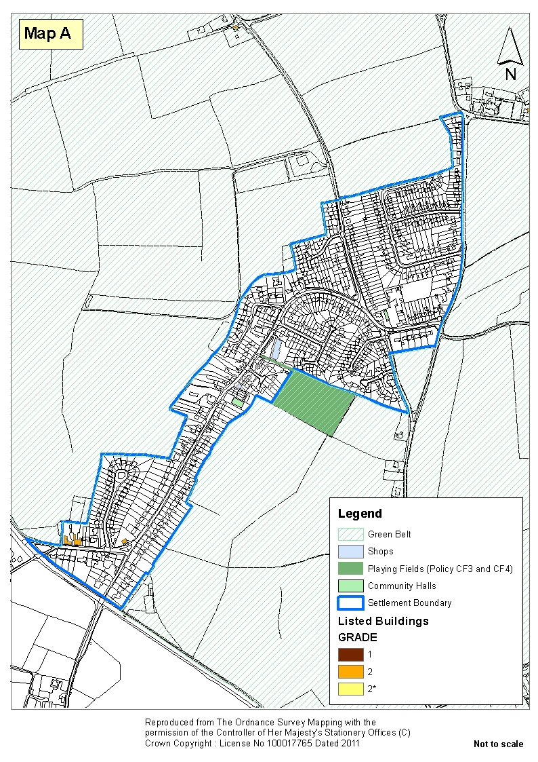

Appendix A
Glossary

Affordable Housing | Affordable housing includes social rented and intermediate housing, provided to specified eligible households whose needs are not met by the market. Affordable housing should:  - Meet the needs of eligible households including availability at a cost low enough for them to afford, determined with regard to local incomes and local house prices  - Include provision for the home to remain at an affordable price for future eligible households or, if these restrictions are lifted, for the subsidy to be recycled for alternative affordable housing provision.
Conservation Area | Areas of special architectural or historic interest, the character, appearance or setting of which it is desirable to preserve or enhance.
Exception site | An exception site is one that would not usually secure planning permission for housing, for example agricultural land next to but not within a local settlement area.
Heavy Goods Vehicle | A heavy goods vehicle means a mechanically propelled road vehicle designed or adapted to have a maximum weight exceeding 3,500 kilograms when in normal use and travelling on a road laden.
Local Centre | Small shops and perhaps limited services, serving a small catchment. Sometimes also referred to as a local neighbourhood centre.
Listed buildings | A "Listed Building" is one which has been formally declared to be of 'special architectural or historic interest' by being placed on statutory lists compiled by the Secretary of State for Culture, Media and Sport under the Planning (Listed Buildings and Conservation Areas) Act 1990. Listing ensures that the architectural and historic interest of the building is carefully considered before any alterations, either outside or inside, are agreed.
Local list | These are buildings that are not necessarily listed, but have a special interest because of:  - Association with well-known local historic persons or events.  - Special architectural interest i.e. a good example of its building type and/or the work of an architect of local importance.  - Special historic (i.e. social, industrial or cultural) interest. (Most buildings and places will fall into this category).  - Contribution to the streetscape/townscape i.e. part of a group of buildings that make up an attractive scene.
Local Lettings  Plans | From time to time a local lettings plan may be agreed between Lichfield District Council and the relevant Housing Association for specific areas or developments to reflect local circumstances. Any such plan will be published and have regard to considerations such as the social mix, density, age and community stability. Any such plan will be time limited but during that time properties may be let to applicants outside the normal rules for priority and banding included in this policy.
Local Plan: Strategy | The local plan strategy contains the broad policy directions and long term strategy to manage development, infrastructure and services across the District. The strategy consists of strategic policies which set out how the strategy will be implemented and monitored.

Appendix B
Stonnall Design Guide

Introduction

Stonnall is a village which over centuries has grown incrementally with a variety of styles of housing reflecting the trends of the times in which they were built. Consequently it is difficult to define a distinctive character other than to say the village comprises a mix of housing ranging from small, low-rise flats and bungalows to large, 5-bed detached dwellings. Similarly the quality of buildings differs between relatively poor units in need of refurbishment to high end, modern family homes.

Architectural style and quality is also quite variable. It is probably fair to say that a large proportion of houses built in the 1960’s whilst being popular and well-built could not be defined as having any special design attributes. More modern phases of development are of higher design quality and create street scenes which positively contribute to the village character. However Stonnall continues to be a desirable place to live with consistent demand from incoming residents for available housing of all ages.

A series of design guidelines have therefore been developed following full consultation with village residents. These guidelines are intended to provide a checklist which will broadly shape the design and layout of new development - attempting to avoid what is felt to be inappropriate and out of keeping, whilst encouraging any new development to be of the highest quality so that it will enhance the character of the village. Where there is consistency with the Lichfield District Design Code 2024 Supplementary Planning Document (https://www.lichfielddc.gov.uk/downloads/download/426/district-design-code-supplementary-planning-document), the relevant code reference is included.

Design guidance

- New development should, wherever possible, conform to existing building lines. This will ensure that the street scene is respected and new building does not project towards the highway. This aligns with Lichfield District Design Code VA3.3.

- Respecting point 1, buildings should be set back from the highway to allow car access and some frontage parking. This is to ensure that vehicles do not need to be parked on the highway in the interests of road and pedestrian safety.

A typical, clear building line (5m from the front of the property) allowing car parking on the frontage
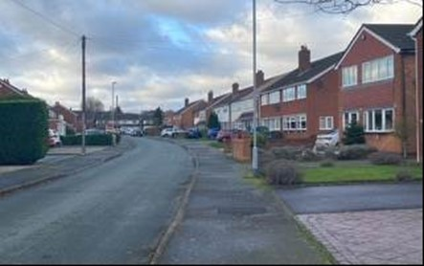

An example of a poor parking arrangement - potentially impinging upon pedestrian safety and restricting drivers’ visibility
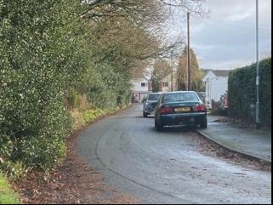

- Frontage areas should not be dominated by car parking. A proportion of the frontage area should provide a soft landscaped area with low lying plants and shrubs.

A good example of railings and soft landscaping clearly defining the front boundary of the property
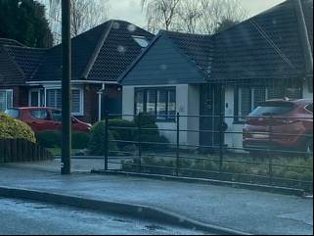
An example of where shrubs can successfully define the edge of the plot
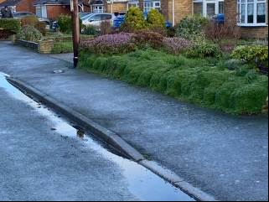

- New buildings should in general be a maximum of two stories. Two and a half storey properties (i.e. two storey with dormers in the roof space) could also be considered but should have an eaves height of no more than 6m. This aligns with Lichfield District Design Code VA3.8.

- Steeper roof pitches than those in surrounding properties should be avoided. Total heights must be no greater than 3m above the eaves heights, with the exceptions of chimneys and aerials. This aligns with Lichfield District Design Code VA3.8.

- In general, grey slate or terracotta roof tiles should be used unless clearly out of keeping with the adjacent properties (e.g. some properties in the village have been built with an attractive blue brick and therefore new/renovated properties adjacent or very close to these could also consider using blue brick). Roof pitch, ridge height and form should be the same amongst new development. This aligns with Lichfield District Design Code VA4.6.
A typical example of a 45 degree roof pitch with grey roof tiles
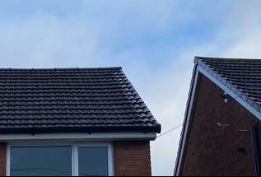

- New housing should be constructed predominantly of red brickwork in keeping with surrounding properties. This aligns with Lichfield District Design Code VA4.7. Reclaimed or locally sourced materials should be used if availability and viability allows.

A good use of red reclaimed brickwork
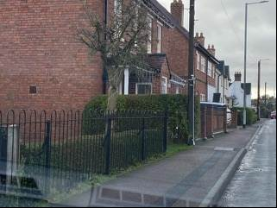

- Wood or composite cladding or rendering could be acceptable to provide contrast and design interest, i.e. as part of a mix with brickwork. However, it should not cover a large area of the building. Metal cladding is not considered to be appropriate. This aligns with Lichfield District Design Code VA4.7.

Examples of an appropriate balance between rendering and brickwork
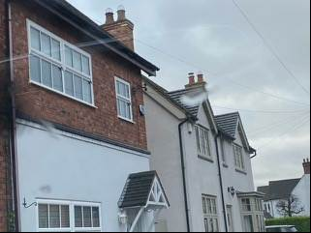

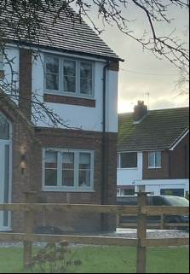

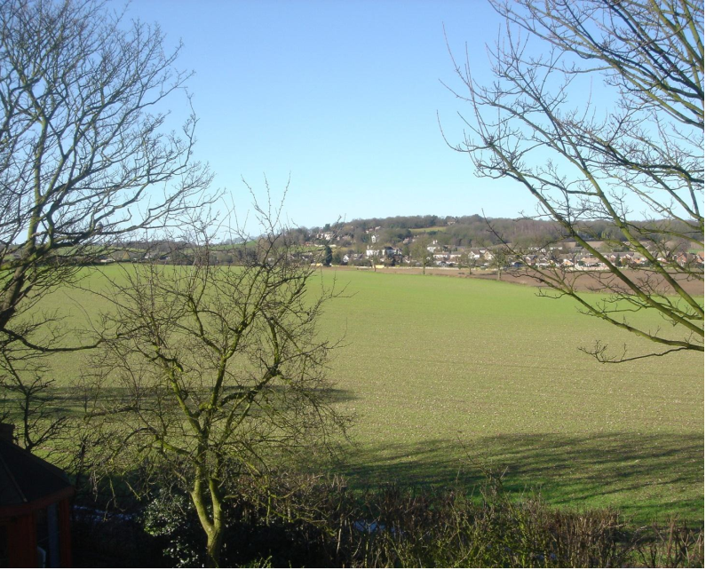
Stonnall Neighbourhood Plan 2014 – 2029
Appendix D
Stonnall Village Design Statement

Priority habitats are identified in the UK Biodiversity Action Plan (https://www.gov.uk/government/publications/biodiversity-the-uk-action-plan)

