Some Ideas to help support lonely people in your area

Post suggestion | Photo
Let’s Beat Loneliness TOGETHER! 🙌  Give an elderly friend or relative a call, Facetime your friends, or send someone you haven’t spoken to in a while a positive text. You know that it will brighten both of your days! 😄  For more tips you can visit  http://bit.ly/LetsBeatLoneliness  #LetsBeatLonelinessTogether #DoingOurBit | 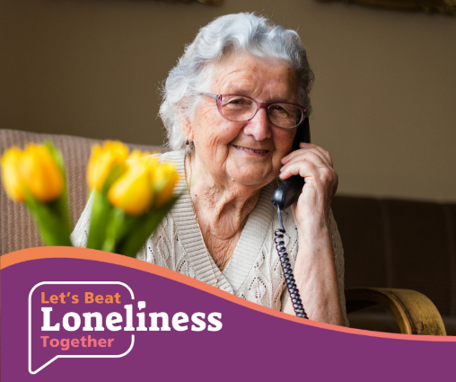

Let’s Beat Loneliness TOGETHER! 🙌

That quick ‘hello’ to your neighbour over the garden fence, might be the only person they speak to all day. 👋

🏡

Take a few extra moments to ask them how they are feeling. It could brighten their day and show that you care. 😄

For more tips you can visit
http://bit.ly/LetsBeatLoneliness

#LetsBeatLonelinessTogether #DoingOurBit

Let’s Beat Loneliness TOGETHER! 🙌  Some people have been self-isolating at home alone for a long time. 🏡 Becoming a telephone befriender can be a great way to give back and help these people connect to the outside world. Search for local volunteering opportunities today by visiting http://bit.ly/DoItStaffs  #LetsBeatLonelinessTogether #DoingOurBit | 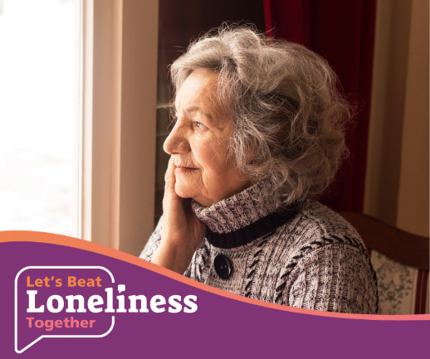
Let’s Beat Loneliness TOGETHER! 🙌  Asking ‘how are you doing?’ to your neighbour over the garden fence, can make their day. 💬  You might be the only person they have spoken to all day…🏡  .  Take a few extra moments to ask them how they are feeling. It could brighten their day and show that you care. 😄  For more tips you can visit  http://bit.ly/LetsBeatLoneliness  #LetsBeatLonelinessTogether #DoingOurBit | 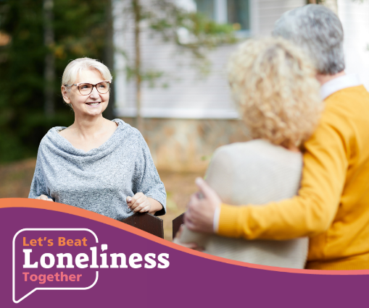
Let’s Beat Loneliness TOGETHER! 🙌  🖥️Online courses can be a great way to meet people, learn new skills and develop interests - all in the comfort of your own home. 🏡 Staffordshire Community Learning offers a wide range of courses to suit everyone - from arts and crafts, languages and creative writing to belly dancing and computing. Visit http://bit.ly/StaffsLearning to browse what’s on offer.  For more tips you can visit  http://bit.ly/LetsBeatLoneliness  #LetsBeatLonelinessTogether #DoingOurBit | 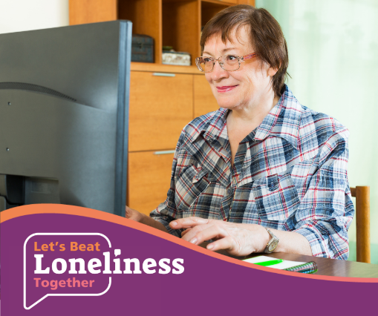
Let’s Beat Loneliness TOGETHER! 🙌  Some people have been self-isolating at home alone for a long time. 🏡 Check up on elderly neighbours and relatives safely. For more tips you can visit http://bit.ly/LetsBeatLoneliness  #LetsBeatLonelinessTogether #DoingOurBit | 